**Module 5: Critical Thinking**

Mohammad Sargazi

Colorado State University Global

CSC450: Programming III

Dr. Haseltine

Nov 12, 2024

1. **Pseudocode**
2. Start Program
3. Prompt User **for** Input

Get text input from the user.

1. Append Input to File

Open CSC450_CT5_mod5.txt in append mode.

Write the user’s input to **this** file.

Close the file.

1. Reverse Contents of File

Open CSC450_CT5_mod5.txt in read mode.

Read all content **and** reverse it.

Open CSC450-mod5-reverse.txt in write mode.

Write the reversed content to CSC450-mod5-reverse.txt.

Close both files.

1. End Program

2**- Source code:**

//============================================================================

// Name : Module5_append.cpp

// Author : MS

// Version :

// Copyright : Your copyright notice

// Description : Hello World in C++, Ansi-style

//============================================================================

**#include** <iostream> // For input/output

**#include** <fstream> // For file handling

**#include** <string> // For string manipulation

// Function to append user input to a file

**void** **appendToFile**(**const** std::**string**& fileName, **const** std::**string**& userInput) {

std::**ofstream** outFile(fileName, std::**ios**::*app*); // Open file in append mode

**if** (outFile) {

outFile << userInput << "\n"; // Write the user's input to the file

} **else** {

std::cerr << "Error: Unable to open file for appending." << std::**endl**;

}

outFile.close(); // Close the file after writing

}

// Function to reverse the contents of one file and save it in another file

**void** **reverseFileContents**(**const** std::**string**& inputFileName, **const** std::**string**& outputFileName) {

std::**ifstream** inFile(inputFileName); // Open input file for reading

std::**ofstream** outFile(outputFileName); // Open output file for writing

**if** (inFile && outFile) {

std::**string** content;

// Read each line and add it to the content string

**while** (std::**getline**(inFile, content)) {

// Reverse the line

std::**string** reversedLine(content.rbegin(), content.rend());

// Write the reversed line to the output file

outFile << reversedLine << "\n";

}

} **else** {

std::cerr << "Error: Unable to open files for reading/writing." << std::**endl**;

}

inFile.close(); // Close the input file

outFile.close(); // Close the output file

}

**int** **main**() {

std::**string** userInput;

std::cout << "Enter text to append to the file: ";

std::**getline**(std::cin, userInput); // Get user input as a line of text

**const** std::**string** inputFileName = "CSC450_CT5_mod5.txt";

**const** std::**string** outputFileName = "CSC450-mod5-reverse.txt";

// Append user input to the file

**appendToFile**(inputFileName, userInput);

// Reverse the content of the input file and save it to the output file

**reverseFileContents**(inputFileName, outputFileName);

std::cout << "Text appended and file reversed successfully." << std::**endl**;

**return** 0;

}

3- **App Screenshot**

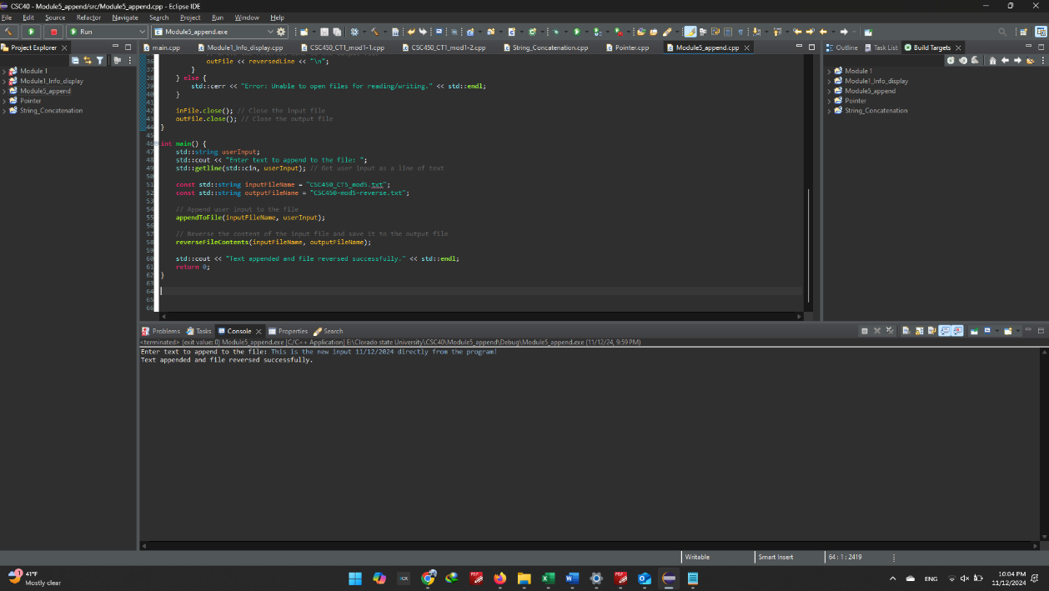

**4- GitHub Screenshot**

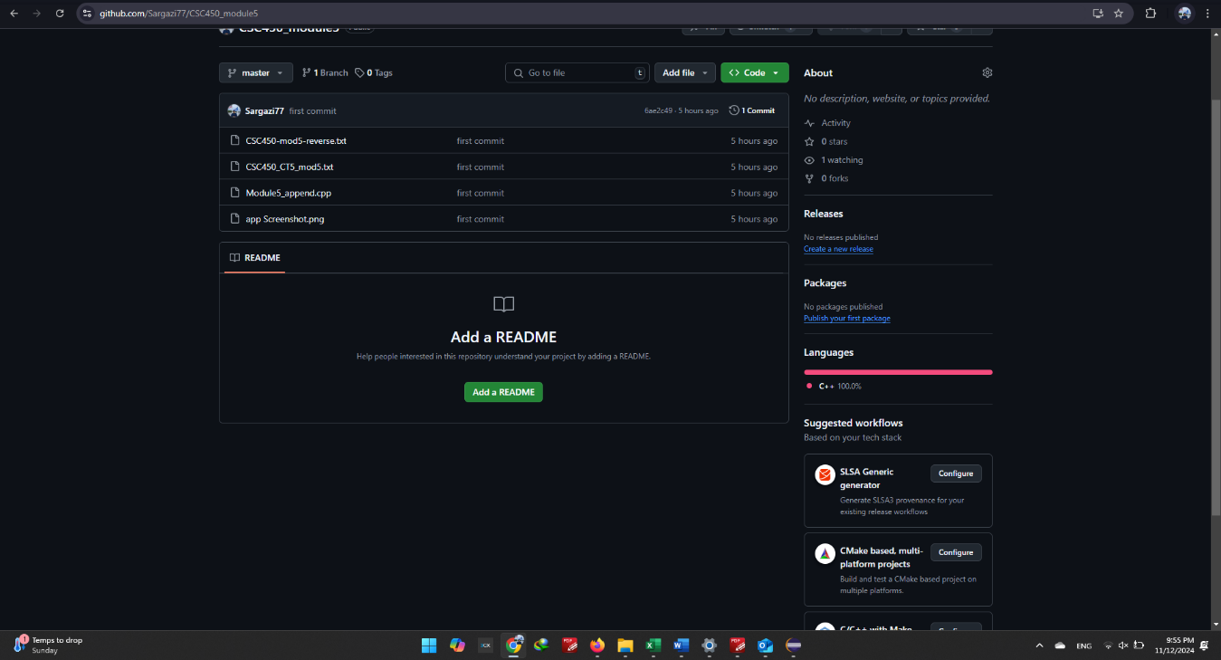

**6- GitHub link:**

<https://github.com/Sargazi77/CSC450_module5>